Infiniti Q50, Q60, and Nissan Z VR30 Maintenance Guide
Written by: Hussain Boxwala
November 27, 2024|
Time to read 14 min
The Definitive Guide to VR30 Maintenance
If you're reading this blog, that means you own an Infiniti Q50, Q60 or Nissan Z with a VR30 Engine. And it also means you've looked into performance modifications and how to make your car fast and reliable. The key to performance AND reliability is to follow a proper maintenance schedule. In this definitive guide, we will walk you through the VR30 maintenance schedule for your Infiniti or Nissan, ensuring that your prized vehicle is always running at its best. Here at Racebox(link opens in new tab/window) we've pooled together our years of experience and over 2500+ tuned VR30s to provide the best recommendations for maintenance and service intervals.
Whether you rely on your car for daily commuting or enjoy the thrill of taking everyone to gapplebees, staying on top of maintenance is vital. From oil changes to fluid checks and spark plug replacements, each component of the maintenance schedule plays a crucial role in keeping your VR30 engine running smoothly and efficiently. By adhering to the recommended maintenance intervals, you can extend the lifespan of your vehicle, prevent expensive repairs, and maintain optimal performance. So, get your pen out or save this to your favorites, because this is THE comprehensive VR30 maintenance schedule, made to ensure that your Infiniti Q50, Q60, or Nissan Z is always in top shape!
Or if you have a short attention span, just look at the chart below. For those that care to know our reasoning, read on!
The Racebox VR30 Maintenance Schedule
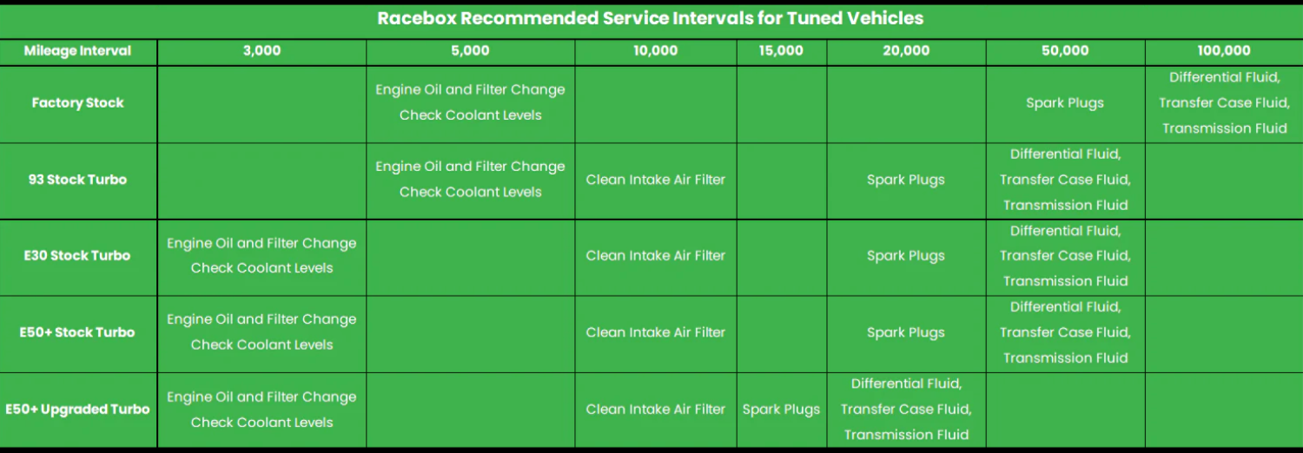(link opens in new tab/window)
Importance of Regular Maintenance for the VR30
Proper maintenance is the cornerstone of keeping your VR30 engine performing at its peak. Regular servicing not only enhances the longevity of your vehicle but also ensures that it operates efficiently. By following a structured maintenance schedule, you can address minor issues before they escalate into major problems, saving you both time and money in the long run.
If you've ever opened a VR30 Facebook page or forum, you may have noticed that although the cars have great potential, they have been plagued with manufacturing defects and failures since their introduction in 2016. As with any other car, spirited driving and extracting the maximum performance out of a car can exacerbate these existing defects and lead to spectacular failures, which is why we created this guide to help our customers, and all VR30 owners, proactively check and maintain their cars to hopefully prevent these failures, or at least keep a tab on them as they occur.
Understand and Listen to your Vehicle!
This wouldn't be a guide by Racebox if we didn't stress the importance of data-logging. Consider yourself extremely lucky that you own a vehicle with such excellent data-logging support. The Infiniti Q50, Q60, and Nissan Z with the VR30 are all supported by EcuTek Technologies tuning suites and with that comes some of the best data-logging you can ask for. If you are tuned you have access to nearly every critical engine parameter that can be accessed by factory OEM tools, at a very high logging rate. This means you can keep track of temperatures, pressures, ignition events, and more!
A few key things that we tell all of our tuning customers: never exceed 3,000 RPM until oil temperature is AT LEAST 170F, fill high quality 93 or ethanol only, never let the car run too hot (Oil and Coolant temps 230+), and watch your charge air temperatures! 99% of problems can be caught early by frequently monitoring your engine's vitals. Watch idle oil pressure (should always be 20+) and WOT oil pressure (50+). Scan for DTCs frequently (many are silent that do not display a CEL on the dash).
Get with your tuner to establish and create a "dashboard" of critical monitors on the ECU Connect App from EcuTek on your tuned vehicle. And if you're not tuned, you can purchase an OTS tune from us and opt to run the stock map for datalogging only if you'd like.
Common issues in the Infiniti Q50, Q60, and Nissan Z VR30
This wouldn't be a comprehensive guide if we didn't go over the major pain points of owning a VR30 powered car. The rest of the guide will speak in detail to each of these failure modes, but in our experience, these are the Top 10 Common Issues we see on the VR30:
1. Snapped serpentine belts and failed pulleys
2. Air locked heat exchanger/intercooler systems
3. Failed injectors
4. Bad turbo seals
5. Broken ground electrodes and insulators on spark plugs
6. Rod bearing failures – “rod knock”
7. Porous blocks and coolant loss
8. Leaking water pumps and bad coolant bypass valves
9. Failed differentials and transfer cases
10. Failed transmissions
Through the rest of this guide we will do our best to address each of these and how you can help prevent them / spot them early.
Oil Changes and Filter Replacements
An oil change is probably the first thing anyone learns to do on their own as they delve into the world of cars and DIY maintenance. And there's a good reason for that - it's the most crucial maintenance item for any combustion engine. While Nissan / Infiniti recommend a 10k oil change interval (OCI), we at Racebox and nearly all of our colleagues and competitors in the industry recommend a much shorter OCI, even on bone stock cars. This is because, on average, our customers and readers are pushing their cars harder than the manufacturer intended, and they want the maximum performance and reliability out of their daily drivers.
On a stock turbo car running 93 fuel, whether tuned or not, we recommend a 5,000 mile OCI. You can do it more frequently if you'd like. You should also always change the filter, and its worth upgrading to the larger OEM filter, Part# 15208-9E01A(link opens in new tab/window), more commonly known as the GTR Filter.
As you step up in performance and start running ethanol blends, fuel dilution in oil becomes more of a concern. While fuel dilution occurs in all direct injected engines to a degree, the issue is exacerbated when running ethanol due to the higher heat of vaporization and tendency to hold water, amongst other things. For this reason, we recommend a 3,000 mile OCI when running E blends. You can always do it sooner if you wish.
And of course, everyone's favorite question: "What oil should I run on my Infiniti Q50, Q60 and Nissan Z VR30 powered car?"
Well, the simple answer is to run fully synthetic oils from any of the major brands. You can do your own research and search for what you think is the best, but with the OCI suggested by us, any full synthetic oil will do just fine. We personally prefer to use Motul on our cars.
As far as viscosity goes, there's quite a few opinions out there. Our official recommendation is to run 5W-20 in motors with under 10,000 miles, 5W-30 in motors with under 75,000 miles, and to step it up to 5W-40 on higher milage motors (75,000+). The more in-depth answer is that these motors are machined with very tight bearing clearances and as there is more wear and the clearances open up, you need to run thicker oil to ensure sufficient lubrication. The danger is running too thick of an oil on a relatively "tight" motor where you actually impede the ability of the oil to freely pass between and lubricate the bearings.
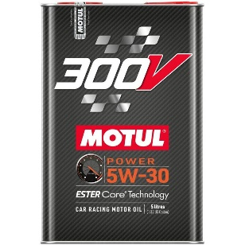
If you're super inclined to delve deeper, you can test for yourself the best oil for your car. Start with 5W-20 and measure oil pressure at idle. Record this, then drain the oil and change to 5W-30. Record the oil pressure at idle again. Then change to 5W-40 and record oil pressure at idle again. Whichever oil weight results in the highest oil pressure at idle, that's the best one for your car. Monitor your idle oil pressure as your car ages in miles and step up oil weight as necessary. The best way to measure and monitor vehicle vitals including oil pressure and others is to use the ECU Connect app paired with the EcuTek Vehicle Interface and a tune.
If you follow the above recommendations and intervals you can save your car from experiencing early rod bearing failure resulting in rod knock while keeping your vehicle performing its best. Frequent oil changes make sure all components are lubricated sufficiently and will help with less wear on all engine components to keep it running like new. It also helps prevent the common turbo seal failure on stock turbos, and will prevent your car from developing smoking issues as it gets up there in mileage.
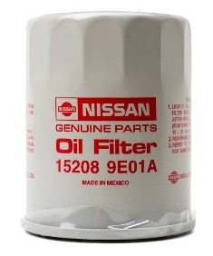

Oil Pressure Solenoid
Modern cars have an oil pressure solenoid that switches the engine oil pump from a "low" to "high" mode. This type of system is present on nearly all modern cars as manufacturers use it to maximize efficiency to meet EPA standards by running lower oil pressure in less demanding scenarios/light driving loads. Your Infiniti Q50, Q60, and Nissan Z VR30 vehicle is also equipped with such a system.
The downside is that this introduces a new failure mode. When the solenoid fails, the car is never able to enter the "high" mode. On the VR30, this results in oil pressure never exceeding 30psi. We observed this phenomenon very early on and have been advising customers to unplug this solenoid and unplugging it ourselves on in-person tunes when needed. Unfortunately, unless you are looking at your logs frequently or having your tuner review logs, you may not catch this. Nissan / Infiniti in their infinite wisdom chose to not have the vehicle throw a code for the oil pressure solenoid failing as the ECU does not check for oil pressure constantly. It really only cares if oil pressure falls below 5psi at idle at which point it will throw a low oil pressure warning on the dash. Unfortunately, by the time this happens, the damage has been done. This oil pressure solenoid silently failing is likely the cause of the majority of bearing/oiling related failures on the VR30.
If you are tuned, we highly recommend unplugging this solenoid, or at the very least monitoring oil pressure at partial and wide-open-throttle loads frequently to ensure you do not face premature bearing wear and engine failure due to lack of lubrication.
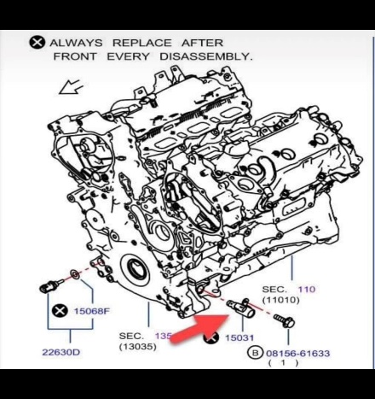
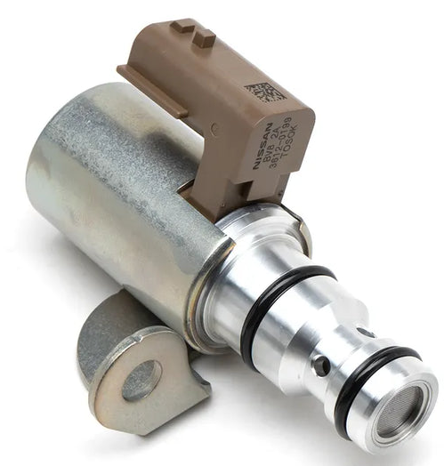

Inspecting and Replacing Spark Plugs
If you ask your service advisor at the dealer about replacing spark plugs, they'll tell you that they are good for the lifetime of the vehicle, or best case recommend a 120,000 mile service interval. This is because laser-iridium plugs like those found on the VR30 are generally long-life plugs compared to the older copper plugs that were used in decades past. However, when running your car hard, and especially when modifying the vehicle to attain double or triple the factory boost levels, you need to consider checking and swapping spark plugs frequently.
On a bone stock factory car, we recommend replacing plugs every 50,000 miles. With a tune and stock turbos, we recommend every 20,000 miles. And on big turbo builds, every 15,000 miles.
Our recommended choice of spark plug is the NGK 97506, gapped to 0.024" for all applications. Consult with your tuner if you think you need to gap them down tighter.
Frequently replacing your spark plugs will result in always having an optimal burn and reducing the chances that you may leave deposits or hot-spots from incomplete combustion cycles, reducing the likelihood of a pre-detonation event that could damage your piston or cylinder wall.
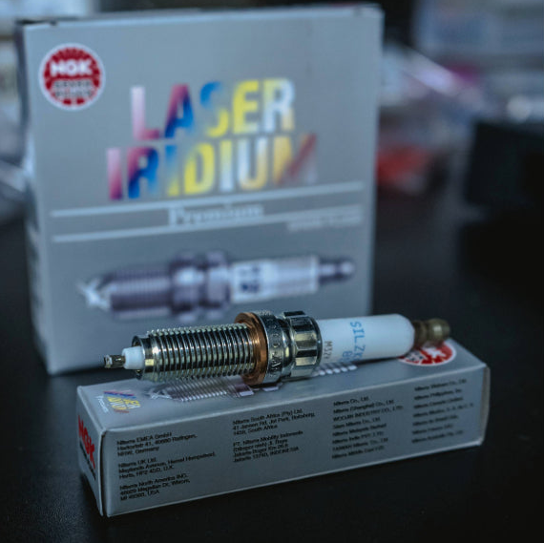

Inspecting and Replacing Drive Belts and Pulleys
The serpentine belt/misaligned idler pulley issue has been well documented on the VR30. The TSB from Infiniti goes as far back as affecting 2016 vehicles. Although Infiniti claims to have solved this issue, there are many documented cases of the serpentine belt coming off on vehicles manufactured as recently as 2024.
You can inspect the pulley alignment visually every oil change (or sooner than that) based on the TSB to hopefully catch the belt slip in the early stages. Additionally, as it gets worse, you'll start hearing a very noticeable "squeak" sound as you accelerate past 3,000 RPM. This is a tell-tale sign that the belt/pulley are out of alignment and failure is imminent.
Due to the location of the failure, if/when the belt does finally slip off, it can damage many other components in the vicinity, including the oil pressure sending unit, the water pump, the A/C compressor, and several other hoses carrying fluids in and out of the engine.
A permanent fix to this can be found in the form of the Racebox x NST upgraded pulley kit which features 3x replacement pulleys machined out of aluminum with grooves and lips to prevent belt slippage once and for all.
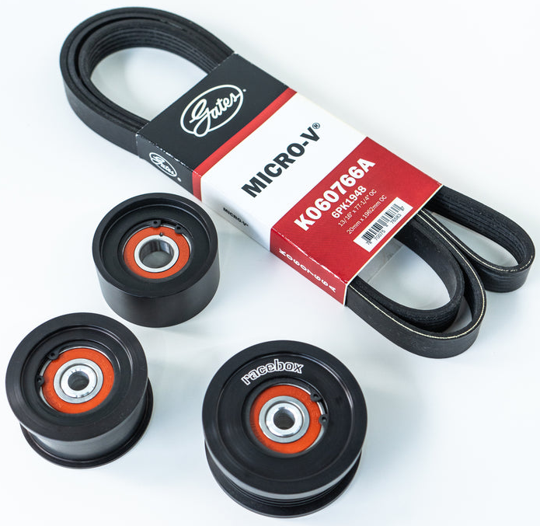
RACEBOX x NST 2023+ Nissan Z & 2016+ Q50 Q60 Upgraded Pulley Kit $337.00
Cooling System Maintenance
Most cars only have one, or at maximum two, water pumps to deal with. These pump the engine coolant through and around the block. Traditionally, even turbocharged cars utilized just one or two pumps for engine coolant, and that was it for coolant-related circuits in the car. However, modern cars, including many new BMWs and especially the VR30, utilize water cooling for the charge air system as well. This introduces another coolant pump on the 300hp models and two pumps on the 400hp Redsport models and the Nissan Z, and along with it, another failure point.
The easiest way to monitor performance of your cooling system is to monitor coolant levels every once in a while and check for changes in level. It's important to check coolant levels when the engine is cold, not while running or hot. On the engine coolant side (the larger reservoir in the case of the VR30), lowering coolant levels could mean a porous block or seal issue. This would be associated with a sweet smell in the exhaust as well. On the other hand, increasing coolant levels could mean oil is mixing with coolant, but you'd definitely notice more severe issues such as rod knock or loss of compression if that were happening.
For the charge air system, the smaller reservoir on the VR30, monitor the level after doing any maintenance or making changes to the system, such as installing extra reservoirs, heat exchangers, intercoolers, or extra pumps. The system may continue to bleed air if not properly bled during install and coolant level will go down. It's important to make sure it is filled adequately to prevent the pumps from locking up and failing.
Luckily, on the VR30, if you scan for codes you will see codes for an "air-locked" charge air cooling system in the form of codes beginning with P14, most commonly P14AC and P14B5. You may also get codes for the pumps having failed from running dry for too long at which point you will need to replace them.
It's important to stay on top of the charge air coolant system as having an air-locked system will result in insanely hot air entering the intake manifold/combustion chamber (we've seen as high as 250F from customers) and risks damaging your engine, even with all of the temperature safeties we put in place.
Transmission, Differential, and Transfer Case Maintenance
This one goes without saying - running your car hard and launching it hard will cook your transmission. Back to back runs and inadequate cooling will result in trans temperatures rising and causing pre-mature wear. We recommend replacing transmission fluid at the 50,000 mile mark for any tuned cars. You can replace it sooner if you observe the transmission flaring on shifts or not shifting fast enough (you're hitting limiter on a shift when you did not used to). Other symptoms may include lazy shifting during daily driving, or harsh shifts as the TCU bumps up line pressure to accomodate for slippage.
The same applies for transfer cases on AWD vehicles and front/rear differentials. If you notice that the car is spinning more than usual on launches, it may be time to check the diff/transfer case fluids. You may also start to get AWD errors when scanning codes, although these are often covered up by the SYVECS AWD controller and you may need to unplug it for codes to pop up. We recommend changing these fluids the same time as the transmission fluid.
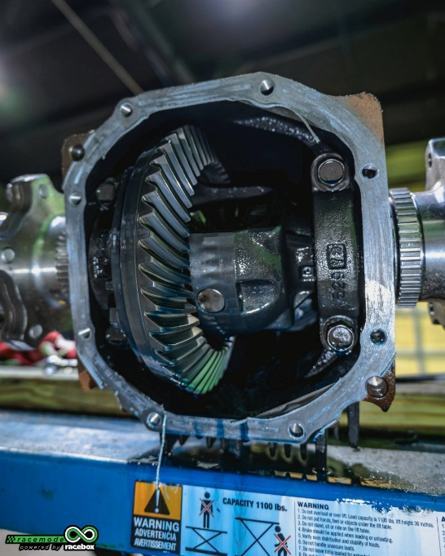
Staying on top of these fluids will not only keep your car running well on the road - it will help you chase record times when optimizing your car for performance.

Direct Injection Fuel System Maintenance
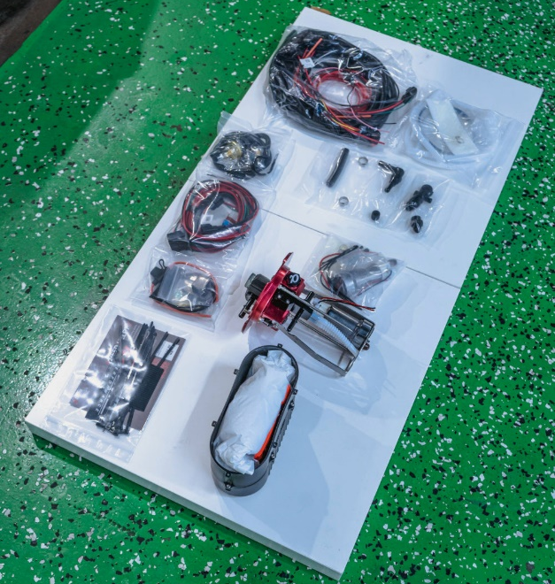
The VR30 engine in the Infiniti Q50, Q60 and Nissan Z features a 200 bar direct injection system. This consists of a low pressure pump found in the tank, a high pressure pump that is cam-driven, and a high pressure rail with DI (direct injection) injectors. Common failure points on DI cars are clogged up direct injectors. What usually occurs when the injectors get clogged is that the solenoid sticks open and floods the cylinder with fuel. This will be characterized by a P0300 and a P030X with X signifying the cylinder that has the failed injector.
The good news is that injectors are relatively easy access on these cars. To avoid these types of failures, fill up good gas and be consistent with the stations you use. Don't fill up at the cheapest station in town and always fill up at top-tier gasoline stations. Consult with your tuner and they can tell you if you've filled up a bad tank of gas when you try out different stations. You should also take care when working on any component of the high-pressure side fuel system - the high pressure pump, rails, and injectors. Anytime the high side is opened up, make sure to be in a dust free environment and cap off any open inlets/outlets to prevent debris from getting into the rails and clogging the injectors.
Another good measure you can take to prevent clogged injectors is to install a fine fuel filter (10 micron or finer) on the feed line going to the HPFP in the engine bay. This will trap nearly all particles small enough to contaminate your DI rail that can come from dirty fuel.
Always monitor fuel pressure when spirited driving and pushing your car to its limits. Low fuel pressure can result in catastrophic engine failure from the cylinders leaning out.

Conclusion and Final Thoughts
The VR30 gets a bad reputation for being "unreliable." While it may not come from factory with forged titanium rods like the LF4, or a closed deck like the B58, the VR30 isn't inherently unreliable. The problem lies on the ECU side with a lack of logic and safeties implemented by Nissan and Infiniti, coupled with a relatively low pressure oil pump and solenoids prone to failing.
The VR30 in your Infiniti Q50, Q60 or Nissan Z CAN be reliable - it just takes a little proactiveness from you, the owner, and some extra time spent understanding values and data logs. If you keep tabs on your vehicle's health, you can join the thousands of Racebox customers who have enjoyed worry-free VR30 ownership with tens of thousands of miles tuned and pushing their cars.
As always, if you have any questions, you can give us a shout. I hope this was helpful!

